Pedestrian access road

**By bus from Fribourg main train station:**

Bus lines 2 (heading to *Les Dailles*) or 11 (heading to *Rosé Gare*)

* **Get off at *Villars-vert***
  + Cross the road and then turn right (towards the freeway)
  + After 50 meters, on the left onto “*Chemin des Eaux-Vives”* (you’ll see a small sign written “*Domaine Notre-Dame de la Route*”)
  + At the end of the road, on the left, you will be arriving at Le Domaine.
  + 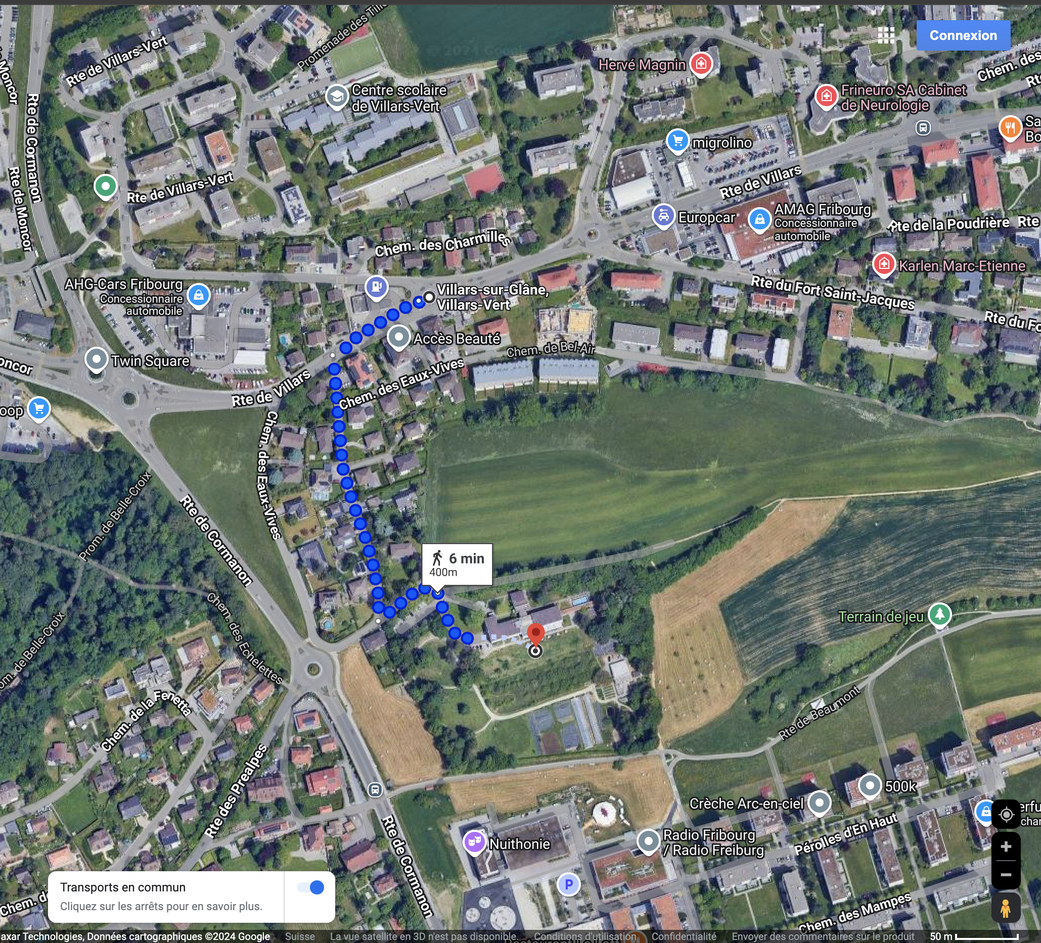Approx. 6 min on foot

**By bus from Fribourg main train station:**

Bus lines 5 (heading to *Villars-sur-Glâne / Cormanon*)

* **Get off at *Nuithonie,*** then you’ll have two options:
  + **The green path:** 
    - Follow the sidewalk until you reach the roundabout
    - Then turn right (at the end of the field)
    - Walk along the road named “Chemin des Eaux-Vives” until you can see the “Domaine Notre-Dame de la Route”. (approx. 5 min on foot)
  + **The blue path:  
    Warning:** This path is **not suitable** for wheelchair users or people with impaired mobility
    - Take the pedestrian path
    - Then turn left at the intersection (you’ll see a wooden portico with the information of the “Domaine Notre-Dame de la Route”)
    - Cross the undergrowth
    - Follow the indications on site
    - You’ll arrive at the Domaine by the restaurant entrance and dining area, the front desk is located on the floor above (floor 0), take the elevator or the stairs to find us. (approx. 7 min on foot)

**On foot if you parked your vehicle at the Fribourg Sud (Fribourg South) shopping centre:**

* Get out of the shopping centre
* Go down in the direction of Fribourg
* Use the pedestrian crossing at “Route de Cormanon”
* Continue towards the “Hôpital Cantonal”
* Take the first street on your right (as a landmark you can see a big publicity panel for “Notre-Dame de la Route” (on the other side of road)
* Take the road named “Chemin des Eaux-Vives”; go all the way to the end of it
* Then take the path on your right and you will have reached your destination
* (Approx. 11 min on foot)

**Warning:** The parking of the Fribourg Sud (Fribourg South) shopping centre is open only during shopping hours:

* Mo-Thur. 8 a.m. to 7 p.m.
* Fri. 8.30 am. to 9 p.m.
* Sat 8 a.m. to 4 p.m.

The first 3 hours are free, then you pay depending on the duration of your parking time. This parking is equipped with charging stations for electrics vehicles.

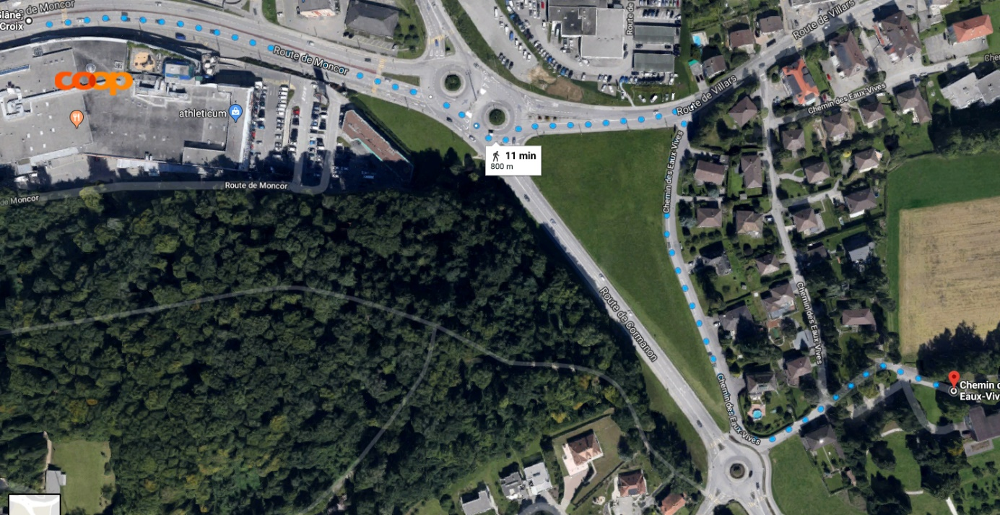

Access road by car

**From the freeway going towards Berne**

* **Get off the freeway at the Fribourg Sud (Fribourg South) exit**
  + Follow the road up to the intersection
  + Take the double roundabout
  + Follow the direction “Hôpital Cantonal” (Hospital)
  + Take the first road on your right after the double roundabout (as a landmark you’ll see a big publicity panel for “Notre-Dame de la Route”)

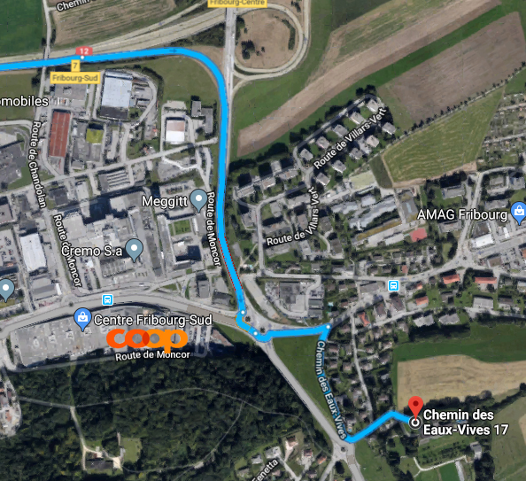

**From the freeway going towards Lausanne:**

* **Get off the freeway at the Fribourg Sud (Fribourg South) exit**
  + Follow the road up to the intersection
  + Take the double roundabout
  + Follow the direction “Hôpital Cantonal” (Hospital)
  + Take the first road on your right after the double roundabout (as a landmark you’ll see a big publicity panel for “Domaine Notre-Dame de la Route”)

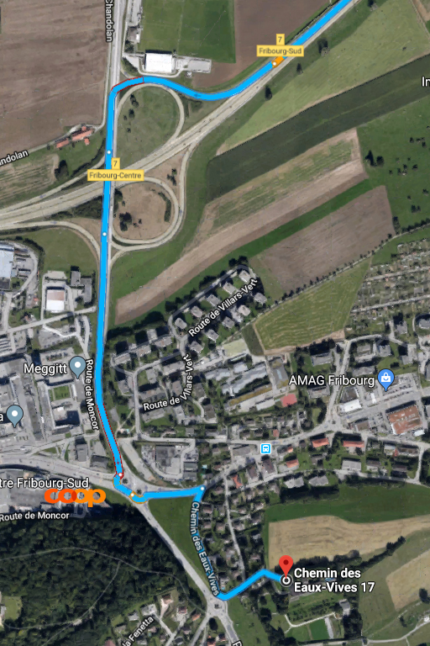

**Information to park your vehicles**

Our establishment offers:

* One large parking area with: 26 spaces
* One small parking area with: 7 spaces
* For disabled costumers we provide: 2 special spaces

**Nearby parking options:**

* ***At the “Chemin des Eaux-Vives”* :**
  + Parking is charged according to local prices
  + Parking meter info: from Mo-Fri, max 3 hours and blue disc use
  + Sat- Sun: free
* **Parking of the *“Cormanon”* centre (Opposite of “Nuithonie”)**
  + Situated only 5 min away on foot from the Domaine
  + Open 24/7
  + **Warning:** this parking is **cash only**
    - Rates depending on the duration of your parking time:
      * From 0 hours to 1h30min free of charge
      * From 1h31min to 2h00min CHF 1.00
      * From 2h01min to 2h30min CHF 2.00
      * From 2h31 min to 3h00min CHF 4.00
      * From 3h01min to 4h00min CHF 8.00
      * From 4h01min to 5h00min CHF 12.00
      * Mo to Thur. from 6 p.m. to 10 p.m.: free of charge
      * Fridays: from 7 p.m. to midnight: free of charges